import numpy as np # linear algebra  
import pandas as pd # data processing, CSV file I/O (e.g. pd.read_csv)  
import seaborn as sns  
import matplotlib.pyplot as plt

df = pd.read_csv('yield_df.csv')

df.head()

Unnamed: 0 Area Item Year hg/ha_yield \  
0 0 Albania Maize 1990 36613   
1 1 Albania Potatoes 1990 66667   
2 2 Albania Rice, paddy 1990 23333   
3 3 Albania Sorghum 1990 12500   
4 4 Albania Soybeans 1990 7000   
  
 average_rain_fall_mm_per_year pesticides_tonnes avg_temp   
0 1485.0 121.0 16.37   
1 1485.0 121.0 16.37   
2 1485.0 121.0 16.37   
3 1485.0 121.0 16.37   
4 1485.0 121.0 16.37

df.drop('Unnamed: 0',axis=1,inplace=True) *# Drop irrelevant column*

df.shape

(28242, 7)

df.info()

<class 'pandas.core.frame.DataFrame'>  
RangeIndex: 28242 entries, 0 to 28241  
Data columns (total 7 columns):  
 # Column Non-Null Count Dtype   
--- ------ -------------- -----   
 0 Area 28242 non-null object   
 1 Item 28242 non-null object   
 2 Year 28242 non-null int64   
 3 hg/ha_yield 28242 non-null int64   
 4 average_rain_fall_mm_per_year 28242 non-null float64  
 5 pesticides_tonnes 28242 non-null float64  
 6 avg_temp 28242 non-null float64  
dtypes: float64(3), int64(2), object(2)  
memory usage: 1.5+ MB

df.isnull().sum()

Area 0  
Item 0  
Year 0  
hg/ha_yield 0  
average_rain_fall_mm_per_year 0  
pesticides_tonnes 0  
avg_temp 0  
dtype: int64

df.duplicated().sum()

np.int64(2310)

df.drop_duplicates(inplace=True)

df.duplicated().sum()

np.int64(0)

# Graph Frequency vs Area

len(df['Area'].unique())

101

plt.figure(figsize=(15,20))  
sns.countplot(y=df['Area'])  
plt.show()

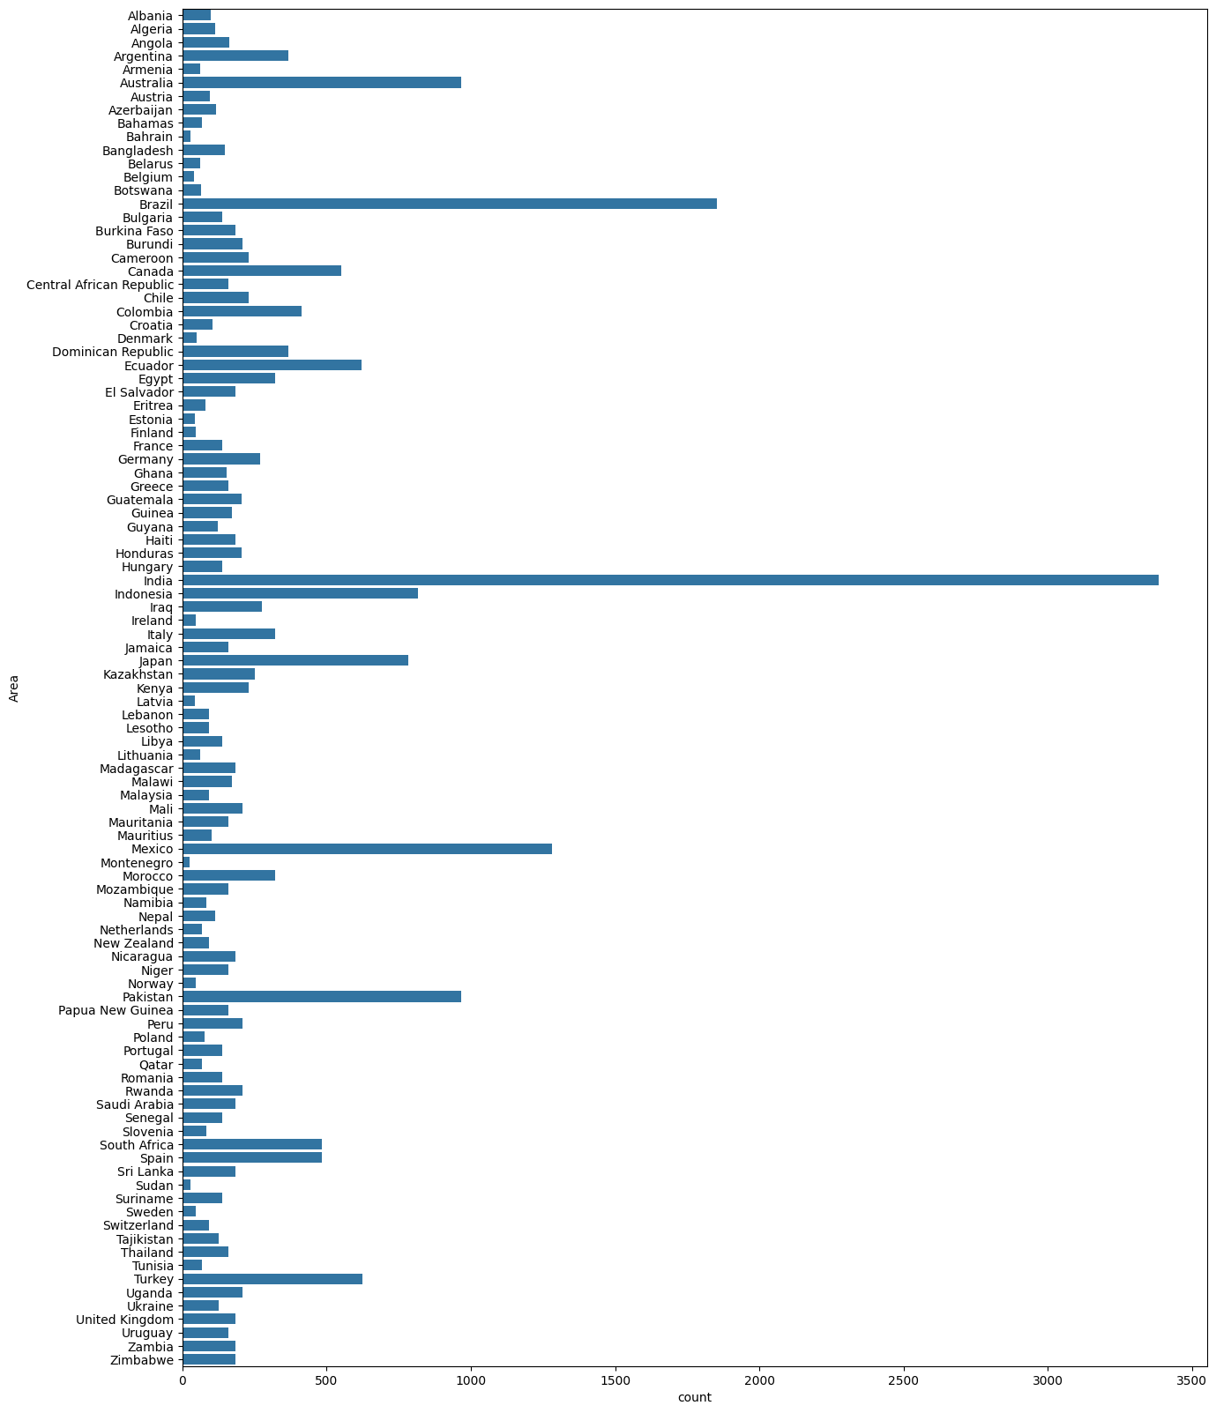

# Yield Per Country Graph

country = df['Area'].unique()  
yield_per_country = []  
for state in country:  
 yield_per_country.append(df[df['Area']==state]['hg/ha_yield'].sum())

plt.figure(figsize=(15, 20))  
sns.barplot(y=country, x=yield_per_country)

<Axes: >

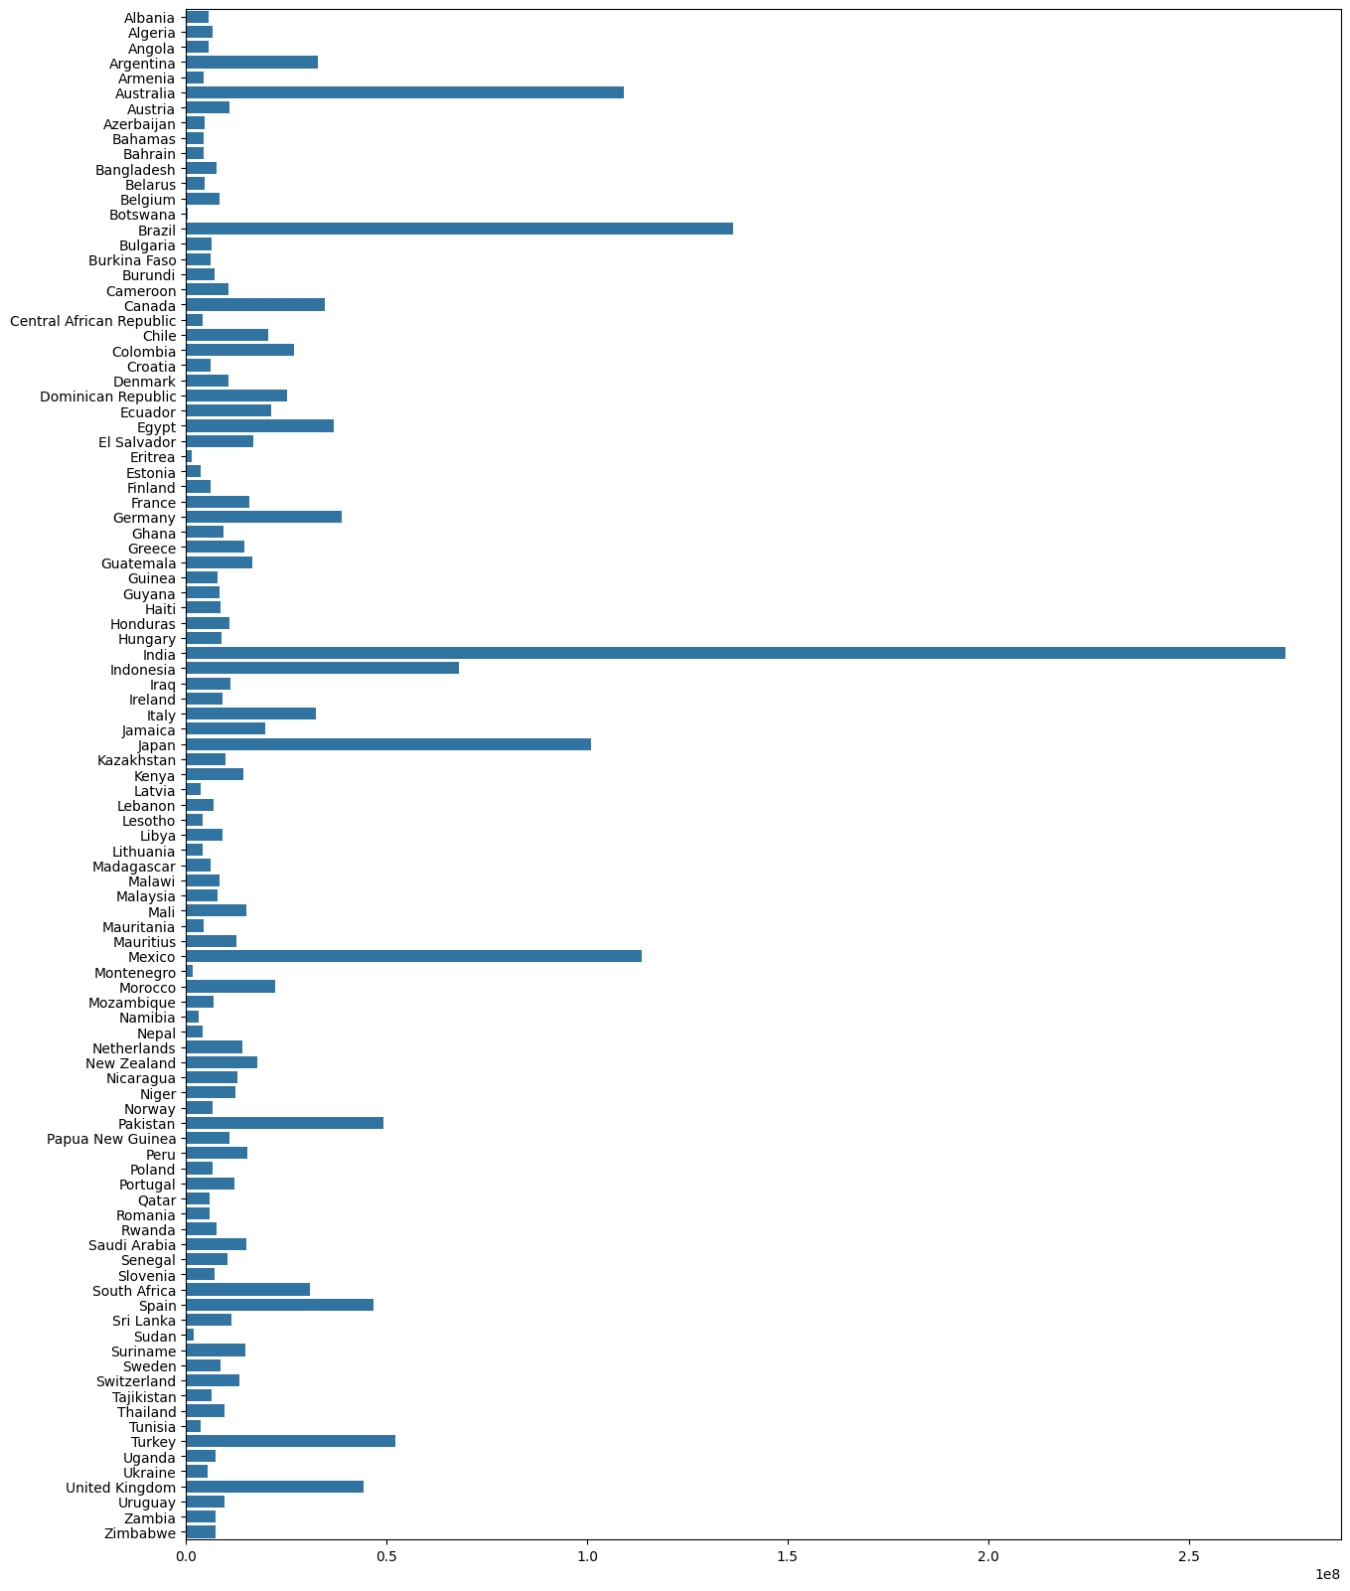

# Graph Frequency vs Item

sns.countplot(y=df['Item'])

<Axes: xlabel='count', ylabel='Item'>

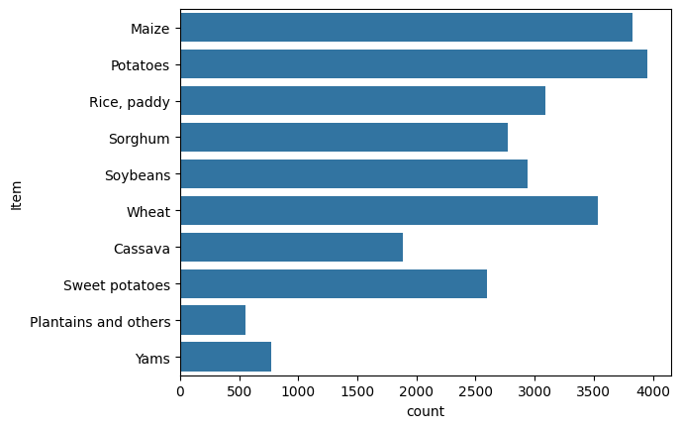

# Yield Vs Item

crops = df['Item'].unique()  
yield_per_crop = []  
for crop in crops:  
 yield_per_crop.append(df[df['Item']==crop]['hg/ha_yield'].sum())

sns.barplot(y=crops,x=yield_per_crop)

<Axes: >

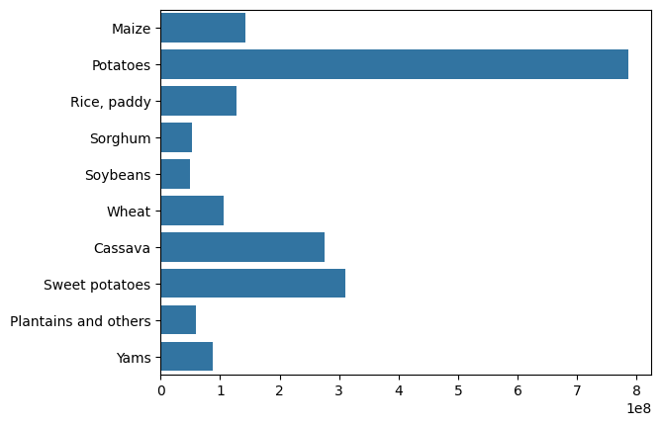

# Train Test split Rearranging Columns

col = ['Year', 'average_rain_fall_mm_per_year','pesticides_tonnes', 'avg_temp', 'Area', 'Item', 'hg/ha_yield']  
df = df[col]  
X = df.iloc[:, :-1]  
y = df.iloc[:, -1]

df.head(3)

Year average_rain_fall_mm_per_year pesticides_tonnes avg_temp Area \  
0 1990 1485.0 121.0 16.37 Albania   
1 1990 1485.0 121.0 16.37 Albania   
2 1990 1485.0 121.0 16.37 Albania   
  
 Item hg/ha_yield   
0 Maize 36613   
1 Potatoes 66667   
2 Rice, paddy 23333

from sklearn.model_selection import train_test_split  
X_train, X_test, y_train, y_test = train_test_split(X, y, train_size=0.8, random_state=0, shuffle=True)

# Converting Categorical to Numerical and Scaling the values

from sklearn.preprocessing import OneHotEncoder  
from sklearn.compose import ColumnTransformer  
from sklearn.preprocessing import StandardScaler  
ohe = OneHotEncoder(drop='first')  
scale = StandardScaler()  
  
preprocesser = ColumnTransformer(  
 transformers = [  
 ('StandardScale', scale, [0, 1, 2, 3]),  
 ('OHE', ohe, [4, 5]),  
 ],  
 remainder='passthrough'  
)

X_train_dummy = preprocesser.fit_transform(X_train)  
X_test_dummy = preprocesser.transform(X_test)

preprocesser.get_feature_names_out(col[:-1])

array(['StandardScale__Year',  
 'StandardScale__average_rain_fall_mm_per_year',  
 'StandardScale__pesticides_tonnes', 'StandardScale__avg_temp',  
 'OHE__Area_Algeria', 'OHE__Area_Angola', 'OHE__Area_Argentina',  
 'OHE__Area_Armenia', 'OHE__Area_Australia', 'OHE__Area_Austria',  
 'OHE__Area_Azerbaijan', 'OHE__Area_Bahamas', 'OHE__Area_Bahrain',  
 'OHE__Area_Bangladesh', 'OHE__Area_Belarus', 'OHE__Area_Belgium',  
 'OHE__Area_Botswana', 'OHE__Area_Brazil', 'OHE__Area_Bulgaria',  
 'OHE__Area_Burkina Faso', 'OHE__Area_Burundi',  
 'OHE__Area_Cameroon', 'OHE__Area_Canada',  
 'OHE__Area_Central African Republic', 'OHE__Area_Chile',  
 'OHE__Area_Colombia', 'OHE__Area_Croatia', 'OHE__Area_Denmark',  
 'OHE__Area_Dominican Republic', 'OHE__Area_Ecuador',  
 'OHE__Area_Egypt', 'OHE__Area_El Salvador', 'OHE__Area_Eritrea',  
 'OHE__Area_Estonia', 'OHE__Area_Finland', 'OHE__Area_France',  
 'OHE__Area_Germany', 'OHE__Area_Ghana', 'OHE__Area_Greece',  
 'OHE__Area_Guatemala', 'OHE__Area_Guinea', 'OHE__Area_Guyana',  
 'OHE__Area_Haiti', 'OHE__Area_Honduras', 'OHE__Area_Hungary',  
 'OHE__Area_India', 'OHE__Area_Indonesia', 'OHE__Area_Iraq',  
 'OHE__Area_Ireland', 'OHE__Area_Italy', 'OHE__Area_Jamaica',  
 'OHE__Area_Japan', 'OHE__Area_Kazakhstan', 'OHE__Area_Kenya',  
 'OHE__Area_Latvia', 'OHE__Area_Lebanon', 'OHE__Area_Lesotho',  
 'OHE__Area_Libya', 'OHE__Area_Lithuania', 'OHE__Area_Madagascar',  
 'OHE__Area_Malawi', 'OHE__Area_Malaysia', 'OHE__Area_Mali',  
 'OHE__Area_Mauritania', 'OHE__Area_Mauritius', 'OHE__Area_Mexico',  
 'OHE__Area_Montenegro', 'OHE__Area_Morocco',  
 'OHE__Area_Mozambique', 'OHE__Area_Namibia', 'OHE__Area_Nepal',  
 'OHE__Area_Netherlands', 'OHE__Area_New Zealand',  
 'OHE__Area_Nicaragua', 'OHE__Area_Niger', 'OHE__Area_Norway',  
 'OHE__Area_Pakistan', 'OHE__Area_Papua New Guinea',  
 'OHE__Area_Peru', 'OHE__Area_Poland', 'OHE__Area_Portugal',  
 'OHE__Area_Qatar', 'OHE__Area_Romania', 'OHE__Area_Rwanda',  
 'OHE__Area_Saudi Arabia', 'OHE__Area_Senegal',  
 'OHE__Area_Slovenia', 'OHE__Area_South Africa', 'OHE__Area_Spain',  
 'OHE__Area_Sri Lanka', 'OHE__Area_Sudan', 'OHE__Area_Suriname',  
 'OHE__Area_Sweden', 'OHE__Area_Switzerland',  
 'OHE__Area_Tajikistan', 'OHE__Area_Thailand', 'OHE__Area_Tunisia',  
 'OHE__Area_Turkey', 'OHE__Area_Uganda', 'OHE__Area_Ukraine',  
 'OHE__Area_United Kingdom', 'OHE__Area_Uruguay',  
 'OHE__Area_Zambia', 'OHE__Area_Zimbabwe', 'OHE__Item_Maize',  
 'OHE__Item_Plantains and others', 'OHE__Item_Potatoes',  
 'OHE__Item_Rice, paddy', 'OHE__Item_Sorghum', 'OHE__Item_Soybeans',  
 'OHE__Item_Sweet potatoes', 'OHE__Item_Wheat', 'OHE__Item_Yams'],  
 dtype=object)

# Let's train our model

#linear regression  
from sklearn.linear_model import LinearRegression,Lasso,Ridge  
from sklearn.neighbors import KNeighborsRegressor  
from sklearn.tree import DecisionTreeRegressor  
from sklearn.metrics import mean_absolute_error,r2_score  
  
  
models = {  
 'lr':LinearRegression(),  
 'lss':Lasso(),  
 'Rid':Ridge(),  
 'Dtr':DecisionTreeRegressor()  
}  
for name, md in models.items():  
 md.fit(X_train_dummy,y_train)  
 y_pred = md.predict(X_test_dummy)  
   
 print(f"{name} : mae : {mean_absolute_error(y_test,y_pred)} score : {r2_score(y_test,y_pred)}")

lr : mae : 29907.52454950499 score : 0.7473119790119538

c:\Users\thero\AppData\Local\Programs\Python\Python312\Lib\site-packages\sklearn\linear_model\_coordinate_descent.py:658: ConvergenceWarning: Objective did not converge. You might want to increase the number of iterations. Duality gap: 67280771830.01953, tolerance: 14848622817.505228  
 model = cd_fast.sparse_enet_coordinate_descent(

lss : mae : 29893.99762450549 score : 0.7473261756207235  
Rid : mae : 29864.881035949216 score : 0.7473041855623102  
Dtr : mae : 3942.563909774436 score : 0.9799132947916251

# Select model

dtr = DecisionTreeRegressor()  
dtr.fit(X_train_dummy,y_train)  
dtr.predict(X_test_dummy)

array([35286., 22814., 19295., ..., 15011., 34879., 79048.])

# Predictive System

def prediction(Year, average_rain_fall_mm_per_year, pesticides_tonnes, avg_temp, Area, Item):  
 # Create an array of the input features  
 features = np.array([[Year, average_rain_fall_mm_per_year, pesticides_tonnes, avg_temp, Area, Item]], dtype=object)  
  
 # Transform the features using the preprocessor  
 transformed_features = preprocesser.transform(features)  
  
 # Make the prediction  
 predicted_yield = dtr.predict(transformed_features).reshape(1, -1)  
  
 return predicted_yield[0]  
  
Year = 1990  
average_rain_fall_mm_per_year =1485.0  
pesticides_tonnes = 121.00  
avg_temp = 16.37   
Area = 'Albania'  
Item = 'Maize'  
result = prediction(Year, average_rain_fall_mm_per_year, pesticides_tonnes, avg_temp, Area, Item)

c:\Users\thero\AppData\Local\Programs\Python\Python312\Lib\site-packages\sklearn\base.py:493: UserWarning: X does not have valid feature names, but StandardScaler was fitted with feature names  
 warnings.warn(  
c:\Users\thero\AppData\Local\Programs\Python\Python312\Lib\site-packages\sklearn\base.py:493: UserWarning: X does not have valid feature names, but OneHotEncoder was fitted with feature names  
 warnings.warn(

result

array([36613.])

# 1990 1485.0 121.00 16.37 Albania Maize 36613  
# 2013 657.0 2550.07 19.76 Zimbabwe Sorghum 3066

# Pickle Files

import pickle  
pickle.dump(dtr,open('dtr.pkl','wb'))  
pickle.dump(preprocesser,open('preprocessor.pkl','wb'))

import sklearn  
print(sklearn.__version__)

1.5.2